Experiment 9
Query with Joins – EquiJoin, InnerJoin, OuterJoin
AIM: To perform JOIN using Equi Join, Inner Join, Outer Join on the given relation.
DESCRIPTION:
JOIN
A MySQL join is a method of linking data from one or more table based on values of the common column between tables.
MySQL supports the following types of joins:
1. Cross join
2. Inner join
3. Left join
4. Right join
CROSS JOIN
The CROSS JOIN makes a Cartesian product of rows from multiple tables. Suppose, you join t1 and t2 tables using
the CROSS JOIN, the result set will include the combinations of rows from the t1 table with the rows in the t2 table.
INNER JOIN
To join two tables, the INNER JOIN compares each row in the first table with each row in the second table to find
pairs of rows that satisfy the join-predicate. Whenever the join-predicate is satisfied by matching non-NULL values,
column values for each matched pair of rows of the two tables are included in the result set.
LEFT JOIN
Unlike an INNER JOIN, a LEFT JOIN returns all rows in the left table including rows that satisfy join-predicate and rows do not. For the rows that do not match the join-predicate, NULLs appear in the columns of the right table in the result set.
1)List the departments where the faculty members are working.
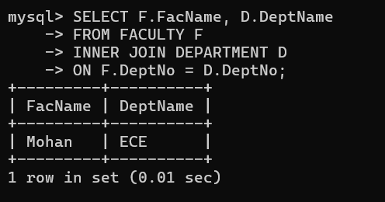

2) Find the student who has no score in any of the courses. List student name and course number.
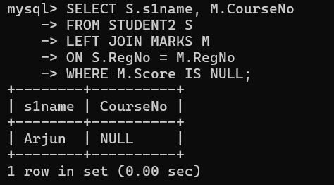

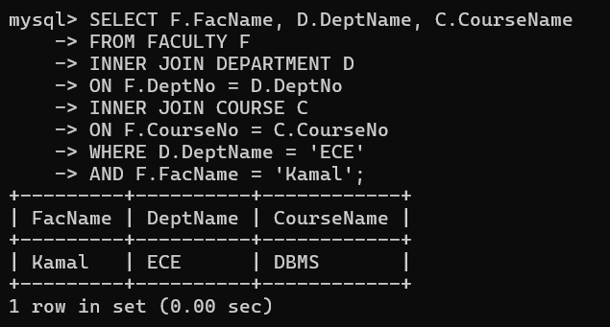
3. The office clerk needs the names of the courses taken by the faculty belonging to ‘ECE department’ whose name is ‘Kamal’.

